NED UNIVERSITY OF ENGINEERING AND TECHNOLOGY

ASSIGNMENT # 01

FUNDAMENTALS OF COMPUTER ENGINEERING(FCE)

COURSE CODE: CS-114

CHAPTER: COMPUTER SYSTEM CABINET

SUBMITTED TO: MS. FAUZIA YASIR

NAME: SYED MUHAMMAD TAIMOOR

SECTION: A

ROLL NO: CS-031

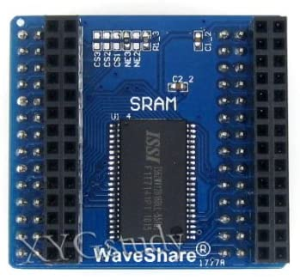SRAM:

Definition:

SRAM stands for **Static Random-Access Memory**. A fast memory technology that requires power to hold its content. Static RAM is fast because the six-transistor configuration of its pretzel-like flip-flop circuits keeps current flowing in one direction or the other (0 or 1). (link: <https://www.pcmag.com/encyclopedia/term/static-ram>)

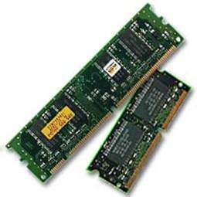A type of RAM that is quicker than dynamic RAM and does not need to be refreshed. SRAM is expensive.

Applications:

SRAM is primarily used for caching. SRAM is sometimes used for system RAM, but that's limited to very specific computers that need to be as fast as possible (it's not a consumer, enthusiast or workstation thing. Or even a normal server thing). (link: <https://linustechtips.com/topic/920328-usage-of-sram/>)

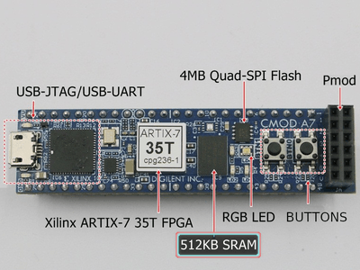Due to its relative simplicity, SRAM is the most common memory cell found in modern [microprocessors](https://en.wikichip.org/wiki/microprocessors). It is used for various large buffers and caches. (link: <https://en.wikichip.org/wiki/static_random-access_memory>)

Static RAM (SRAM, S-RAM) is used for high-speed registers, caches and relatively small memory banks such as a frame buffer on a graphics card. (link: <https://www.pcmag.com/encyclopedia/term/static-ram>)

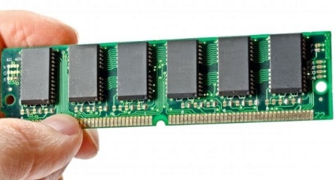Logic or circuitry is needed, so the memory module itself is simpler. (link: <https://www.guru99.com/sram-vs-dram-difference.html#7>)

Pictures:

<https://www.amazon.com/Storage-IS62WV12816BLL-Memory-Evaluation-Development/dp/B00DUEQMVY>

<https://www.ebay.co.uk/p/8006037001>

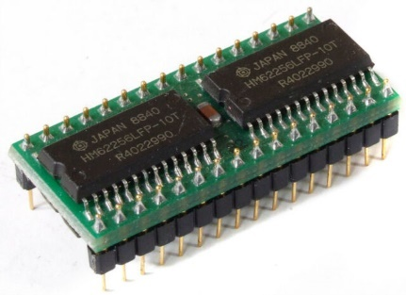<https://www.tutorialspoint.com/computer_fundamentals/computer_ram.htm>

<https://www.egypt-business.com/brochure/details/1804-worldwide-static-random-access-memory-sram-market-forecasts-to-2022/211123>

<https://www.hackster.io/salvador-canas/a-practical-introduction-to-sram-memories-using-an-fpga-i-3f3992>

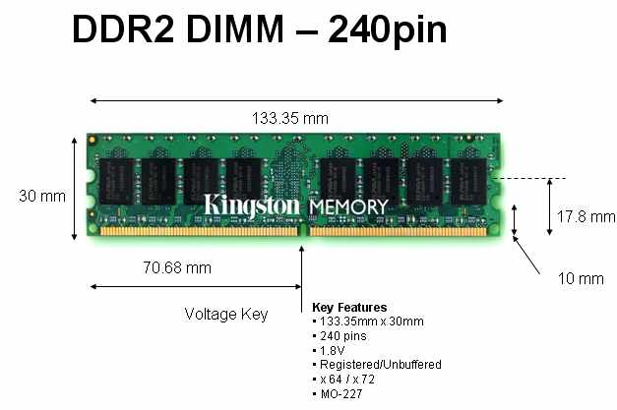DIMM:

DEFINITION:

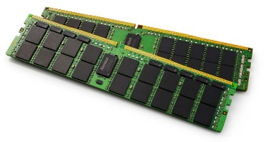DIMM (dual inline memory module) has RAM chips on only one side. A RAM is a chip made up of several electronic elements that store the temporary working data of your system which can be read and written. RAM requires electric supply for functioning, hence when the system is turned off, all data from RAM vanishes. It is mounted on the motherboard. (link: <https://www.geeksforgeeks.org/what-is-dimmdual-inline-memory-module/>)

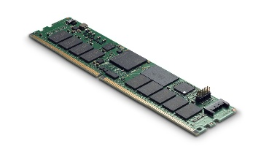A DIMM is a small circuit board that holds memory chips. It uses a 64-bit bus to the memory. (link: <https://techterms.com/definition/dimm>)

Applications:

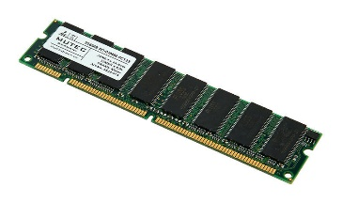DIMM allows to transfer more data at once. Because DIMMs have faster data transfer capabilities. (link: <https://techterms.com/definition/dimm>)

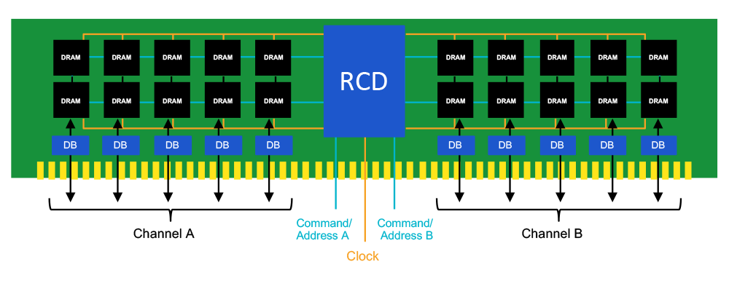Modern Pentium computers use this memory module. Dual In-Line memory module consumes only 3.3 volts of power. (link: <https://www.javatpoint.com/dimm>)

DIMMS come in a variety of packages, each with a different amount of pins and applications. Their uses include SDRAM (Synchronous Dynamic Random-Access Memory), DDR (Double Data Rate), DDR2 and DDR3. (link: <https://www.helpwithpcs.com/jargon/dimm_dimms.htm>)

The DIMM is installed on a motherboard and stores each data bit in separate memory cells.

Pictures:

<https://www.thomann.de/gb/mutec_dimm_sdram_256mb.htm>

<https://www.rambus.com/blogs/get-ready-for-ddr5-dimm-chipsets/>

<https://www.extremetech.com/computing/259155-micron-launches-new-nand-based-dimms-intel-announces-optane-dimms>

<https://www.simmtester.com/News/PublicationArticle/168>

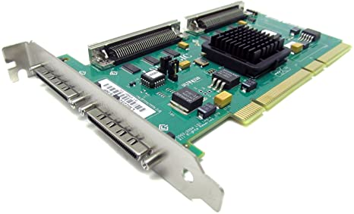SCSI PORT:

DEFINITION:

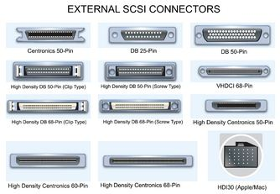SCSI (small computer system interface) port allows data to be transmitted in a “daisy chain” up to seven devices at speeds (32 bits at a time) higher than those possible with serial and parallel ports.

A small computer systems interface (SCSI) is a standard interface for connecting peripheral devices to a PC. Depending on the standard, generally it can connect up to 16 peripheral devices using a single bus including one host adapter. (link: <https://www.techopedia.com/definition/331/small-computer-system-interface-scsi>)

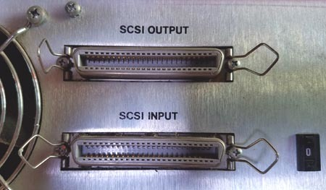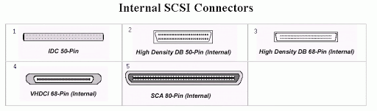The Small Computer System Interface (**SCSI**) is a set of parallel interface standards **developed** by the American National Standards Institute (ANSI) for attaching printers, disk drives, scanners and other peripherals to computers. **SCSI** (pronounced "skuzzy") is supported by all major operating systems. (link:<https://www.webopedia.com/TERM/S/SCSI.html#:~:text=The%20Small%20Computer%20System%20Interface,by%20all%20major%20operating%20systems>)

APPLICATIONS:

SCSI is used to increase performance, deliver faster data transfer transmission and provide larger expansion for devices such as CD-ROM drives, scanners, DVD drives and CD writers. SCSI is also frequently used with RAID, servers, high-performance PCs and storage area networks SCSI has a controller in charge of transferring data between the devices and the SCSI bus. Each device on a parallel SCSI bus must be assigned a number between 0 and 7 on a narrow bus or 0 and 15 on a wider bus. This number is called an SCSI ID. SCSI also allows backward compatibility where devices were compatible with earlier version of SCSI. (link:<https://www.techopedia.com/definition/331/small-computer-system-interface-scsi>)

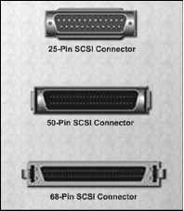PICTURES:

<https://www.ccexpert.us/operating-systems/scsi-ports-and-cables.html>

<https://www.pcmag.com/encyclopedia/term/scsi>

<https://www.what-is-my-computer.com/scsi-ports.html>

<https://www.amazon.com/HP-A6961-60011-2-Port-Ultra320-SCSI/dp/B00IYX3ME6>

<http://www.scsi4me.com/scsi-connectors.htm>